Axial vs. Appendicular Skeleton

* **axial skeleton:** consists of the bones that lie around the longitudinal _______________ of the body
* **appendicular skeleton:** consists of bones of the upper and lower _______________ + the bones forming the _______________: connecting limbs to the axial skeleton

Cranial Bones

* **skull:** bony framework of the _______________, 22 bones
  + **cranial bones:** those that form the _______________ cavity (8)

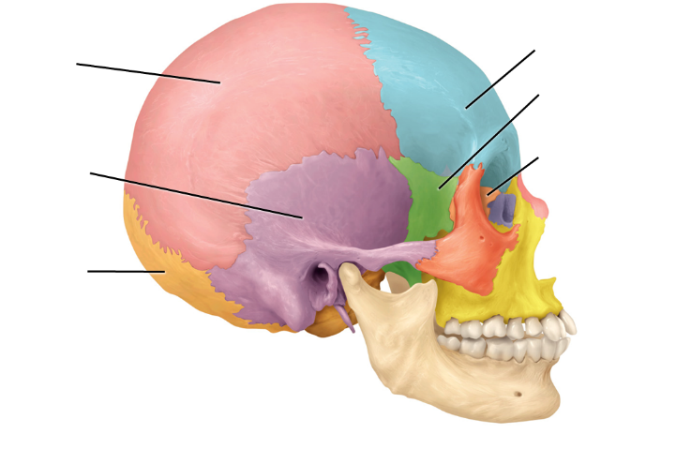 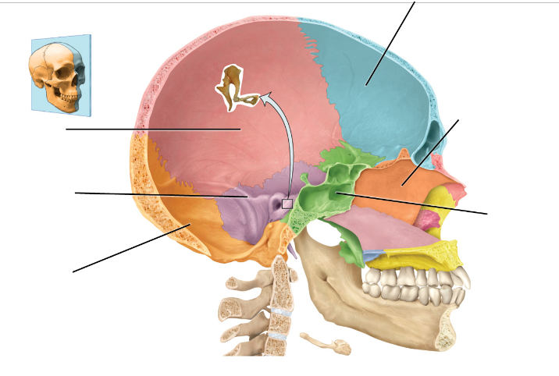

Sphenoid bone

* **sphenoid bone:** lies at the middle part of the _______________ of the skull  
  🡪 “keystone” of the cranial floor b/c it articulates with all the other cranial bones  
  🡪 houses some notable foramen = openings thru which vessels, nerves, ligaments pass

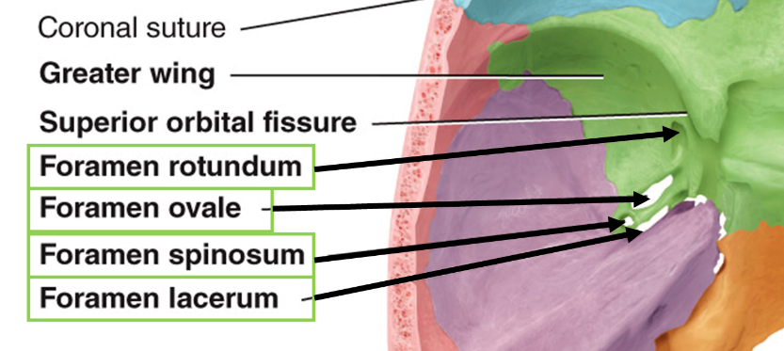

* **optic foramen (canal)**: transmits the optic nerve (CN II) and the ophthalmic artery
* **superior orbital fissure**: transmits the trigeminal (CN V), abducens (CN VI), trochlear (CN IV), and oculomotor nerve (CN III)
* **inferior orbital fissure**: transmits branches of the trigeminal (CN V)
* **foramen rotundum**: transmits the maxillary (branch of CN V, trigeminal)
* **foramen ovale**: transmits mandibular nerve (branch of CN V, trigeminal)
* **foramen spinosum**: transmits the anterior branch of the middle meningeal artery
* **foramen lacerum**: transmits branch of ascending pharyngeal artery

Ethmoid bone

* **ethmoid bone:** forms the…
* [1] anterior part of the _______________ floor
* [2] medial wall of the _______________
* [3] superior portion of the _______________ _______________
* [4] most superior supporting structure of the nasal cavity

**[1] cribriform plate**: lies in the anterior floor of the cranium and forms the _______________ of the _______________ _______________  
🡪 contains the olfactory foramina through which the olfactory nerves pass

**[2] crista galli**: projects superiorly from the cribriform plate and serves as a point of _______________ for the _______________ _______________: membrane that separates brain hemispheres

**[3]** **perpendicular plate**: projects inferiorly from the cribriform plate and forms the superior portion of the _______________ _______________

**[4] lateral masses:** contain air spaces called ethmoidal cells that form the ethmoidal sinus

* superior nasal concha and middle nasal concha: increase vascular and mucus membrane _______________ _______________ in nasal cavity which warms and moistens inhaled air before it passes into the lungs

Cranial Bones – Sutures

* **suture**: an immovable joint (in adults) that holds most _______________ bones together  
  🡪 sutures in the skull of infants and children are often movable and function as growth centers

[1] **coronal suture:** unites _______________ bone with both parietal bones

[2] **sagittal suture:** unites the 2 _______________ bones

[3] **lamboid suture:** unites the 2 parietal bones with the _______________ bone

[4] **squamous sutures** (2): unites the parietal and temporal bones on the _______________ aspects of the skull

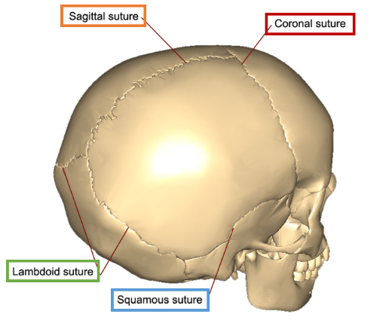

Cranial Bones – Fontanels

* **fontanel** (aka “_______________”): areas where unossified mesenchyme develops into dense connective tissue of the skull   
  🡪 as bone formation continues after birth, the fontanels are eventually replaced with bone and the thin collagenous connective tissue junctions that remain between neighboring bones become the sutures

Facial Bones

* **skull:**  
  [2] **facial bones:** form the _______________ (14)

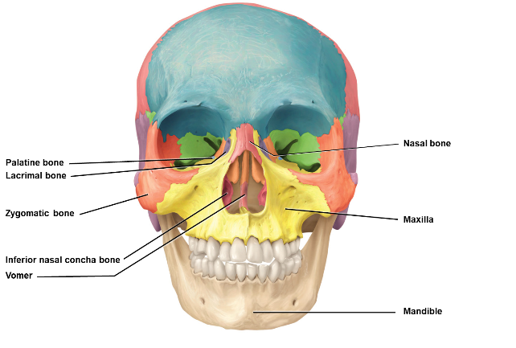

* **maxillae (2):** bones of the _______________ _______________  
  🡪 articulate with every bone of the face except the mandible (lower jaw)   
  🡪 forms part of the orbits, part of the nasal cavity, and most of the hard palate (bony roof of the mouth)  
  🡪 each maxilla contains a large maxillary sinus that empties into the nasal cavity   
  🡪 the alveolar processes of the maxilla are ridge-like arches that contain the alveoli (sockets) for the maxillary (upper) teeth
* **mandible:** largest, strongest facial bone that forms the _______________ _______________  
  🡪 mental foramen: transmits terminal branches of alveolar nerve and mental vessels   
  🡪 mandibular foramen: transmits mandibular nerve and blood vessels
* **inferior nasal conchae (2):** form part of (and project into) the _______________ cavity  
  🡪 separate bones from nasal conchae of the ethmoid bone  
  🡪 all three pairs of nasal conchae (superior, middle, inferior) increase the surface area of the nasal cavity and help swirl and filter air before it passes into the lungs
* **nasal bones (2):** small, flattened rectangular   
  shaped bones that form the _______________ of the nose
* **vomer:** triangular bone that forms the nasal _______________ (along with the ethmoid)  
  🡪 nasal septum = the partition that divides the nasal cavity into L/R sides
* **lacrimal bones (2):** _______________ bones of the face  
  🡪 lacrimal fossa: vertical tunnel formed with the maxilla that houses the lacrimal sac which gathers tears
* **zygomatic bones (2):**  _______________, form the prominences of the cheeks and part of the orbit   
  🡪 zygomatic arch: the temporal _______________ of the zygomatic bone projects posteriorly and articulates with the zygomatic process of the temporal bone
* **palatine bones (2):** form the posterior portion of the _______________ _______________, part of the nasal cavity, and a small portion of the orbits

Special Structures

* **hard palate:** _______________ of the mouth, formed from **maxillae + palatine**
* **nasal septum:** separates nose into left and right, composed of _______________**,** _______________ **bone (perpendicular plate),** and_______________ cartilage
* **orbit:** (aka orbital cavity, eye socket) contains the _______________ and associated structures  
  🡪 comprised of 3 cranial bones = **frontal, sphenoid, ethmoid** 4 facial bones = **palatine, zygomatic, lacrimal, maxilla**
* **paranasal sinuses:** _______________ within certain cranial and facial bones near the nasal cavity  
  🡪 lined with mucus membranes that are continuous with the lining of the nasal cavity  
  🡪 sinuses increase the surface area of the nasal mucosa, thus increasing the production of mucus to help moisten and cleanse inhaled air  
  🡪 small or nearly absent at birth, allow the skull to increase in size without a change in the mass of the bone

Hyoid Bone

* **hyoid bone   
  🡪** _______________ _______________ with ANY other bone   
  🡪 suspended from the styloid processes of the temporal bones by ligaments and muscles   
  🡪 supports the tongue, providing attachment sites for some tongue muscles and for muscles of the neck and pharynx

Vertebral Column

* **vertebral column** (aka “spine” “backbone” “spinal column”)  **🡪** makes up about _______________ of your total height   
  🡪 contains a series of bones called **vertebrae** organized into 5 regions  
   [1] cervical [2] thoracic [3] lumbar [4] sacral [5] coccygeal

* **vertebral body:** the thick, _______________-_______________ anterior portion; the weight-bearing part of the vertebra
* **vertebral foramen:** accommodates the spinal _______________
* **processes**: 7 processes arise from the vertebral arch   
   [1] transverse process - (2) extends _______________ on each side   
   [2] spinous process – projects _______________ from the junction of the laminae   
   [3] superior articular processes – (2) _______________ with the 2 inferior articular processes _______________ them   
   [4] inferior articular processes – (2) articulate with the 2 superior articular processes _______________ them
* **intervertebral discs:** fibrocartilage _______________ the bodies of adjacent vertebrae from the 2nd cervical vertebra to the sacrum  
  🡪 fun fact: you are slightly shorter at night because over the course of the day, the discs compress and lose water
* **cervical vertebrae:** C1-C7  
  🡪 _______________ than all other vertebrae, except those that form the coccyx  
  🡪 have 3 foramina: 1 vertebral foramen and 2 transverse foramina (vertebral artery and vein)  
   **C1 = ATLAS   
   C2 = AXIS**
* **thoracic vertebrae:** T1-T12  
  🡪 considerably larger and stronger than cervical vertebrae  
  🡪 _______________ with the ribs
* **lumbar vertebrae:** L1-L5  
  🡪 largest, _______________ of the unfused bones in the vertebral column  
  🡪 the spinous processes are well adapted for the attachment of the large back muscles
* **sacrum:** large triangular bone formed by the _______________ of 5 sacral vertebrae (S1-S5)  
  🡪 sacral vertebrae begin to fuse between 16-18 years of age (process completed by 30)   
  🡪 serves as foundation for the pelvic girdle
* **coccyx** (aka “_______________”): small triangular bone formed by the union of 4 coccygeal vertebrae (Co1-Co4)   
  🡪 fusion occurs between the age of 20-30
* the female sacrum is shorter, wider, and more curved between S2-S3

Thoracic Cage

* **thoracic cage:** bony _______________ formed by the [1] sternum, [2] ribs and their [3] costal cartilages, and the bodies of the thoracic vertebrae
* **sternum** (aka _______________): flat, narrow bone located in the center of the anterior thoracic wall

[1] **manubrium:** the _______________ portion

[2] **body:** the _______________ and largest part

[3] **xiphoid process**: inferior and _______________ part

* **ribs:** 12 pairs, numbered 1-12 from superior to inferior   
  🡪 give structural support to the _______________ of the thoracic cavity   
  🡪 each rib articulates posteriorly with its corresponding thoracic vertebra
* **true ribs** = those that have costal cartilages that attach _______________ to the sternum (1-7)  
  **false ribs** = costal cartilages either attach _______________ to the sternum or do not attach to the sternum at all (8-12)

Clinical Connection

* **scoliosis:** increased _______________ curvature
* **kyphosis:** increased _______________ curvature, bent forward
* **lordosis:** increased _______________ curvature, bent backwards
* **herniated disc:** results from _______________ of an intervertebral disc   
  🡪 the soft inner portion of the disc (nucleus pulposus) protrudes outside through the hard outer ring (annulus fibrosus)  
  🡪 causes pain when a nerve is compressed  
  🡪 can be precipitated by strain, injury, and aging
* **spina bifida:** is a _______________ neural tube defect in which the spinal column does not form properly and neural tissue protrudes from an opening in the back